**Transports in SAP PO (PROCESS ORCHESTRATION) using File System**

Here are the steps that we need to follow to transport objects by using File system.

**Step 1: For Exporting Objects to Local System in ESR.**

Go to Tools 🡪 Export Design Objects

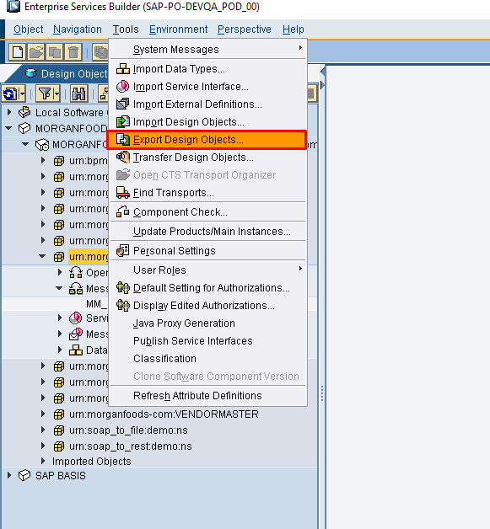

Select software Component Version and check Download File to Client then click on Continue Button

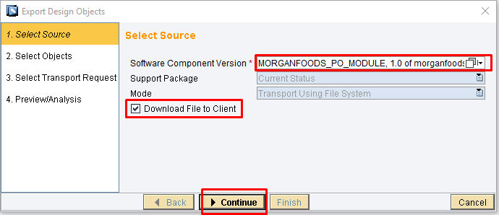

Select ‘Object Set’ as per your requirement

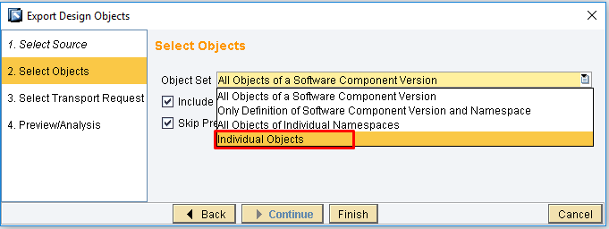

After selection of Object Set you need to uncheck Including Deleted Objects Option and then click on Continue

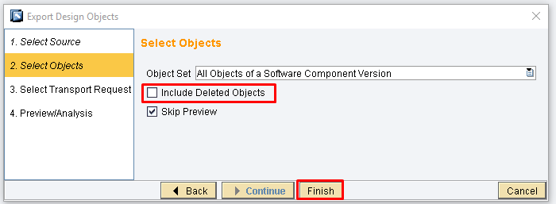

Now you need to drag or select objects from value list. Select the below options based on our requirement. That is if software component or namespace already there in target system no need of selection. Then click on finish button.

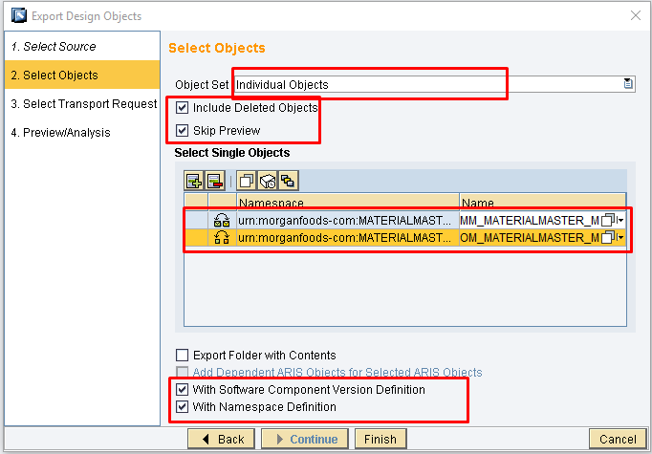

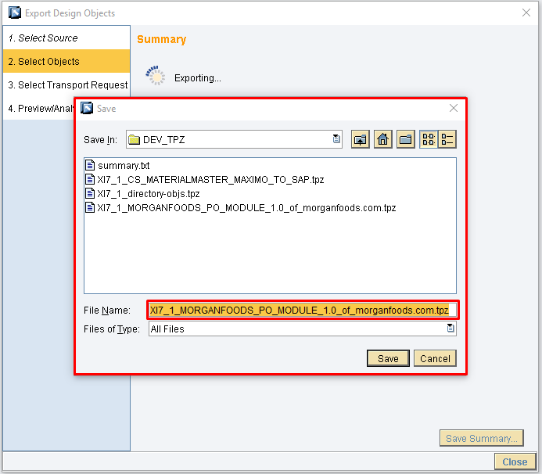

After selection of target directory you will find summary of all objects like below

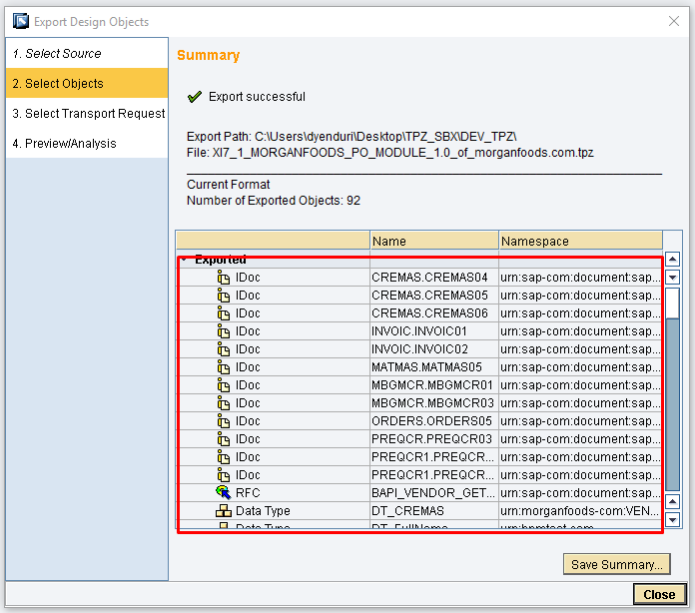

The above steps are for exporting objects to local system.

**Step 2: For Importing Objects from Local System to Target System**

Go to Tools 🡪 Import Design Objects

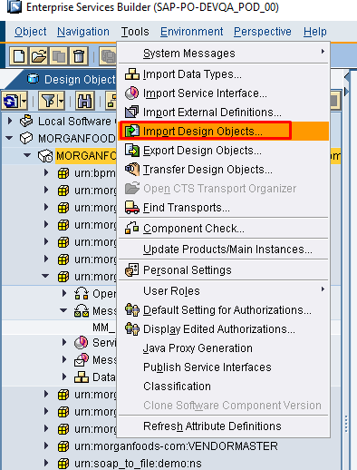

After selection of Import Design Objects will find one dialog box like below from that one you need to select **Client** option

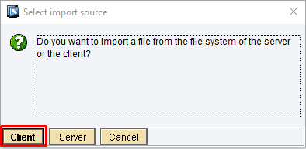

After Selection of Client you need to select the exported file form DEV system

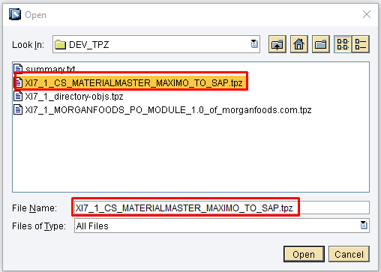

Then you can find all the objects that you transported form source system.

**Exporting and importing of Integration Directory (ID) objects:-**

Go to Tools 🡪 Export Design Objects

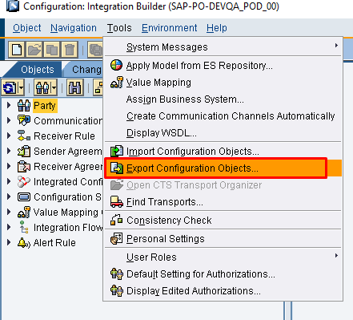

After selection of Export configuration Objects then you will find the below screen form that you need to select which mode you want transport your options. For now we are using File system. Next you need to select continue option.

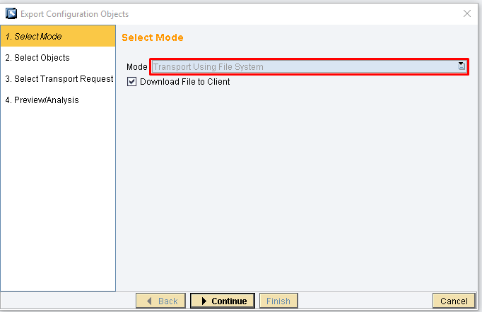

Select object set based on our requirement now I am selecting individual objects.

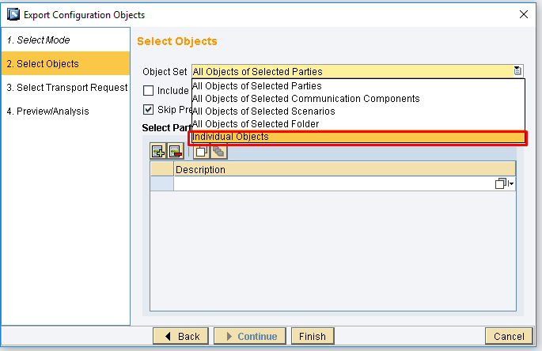

Now you need to drag or select objects from value list. Select the below options based on our requirement. That is if software component or namespace already there in target system no need of selection. Then click on finish button.

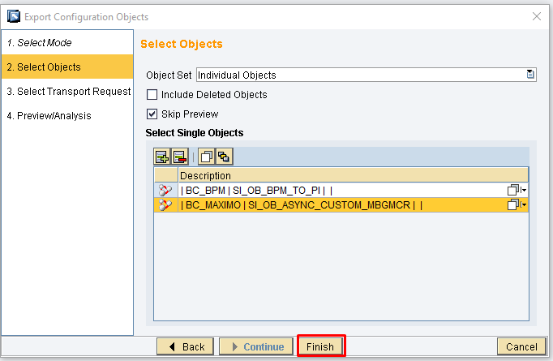

After selection of Finish next step is select the target directory where you want to store.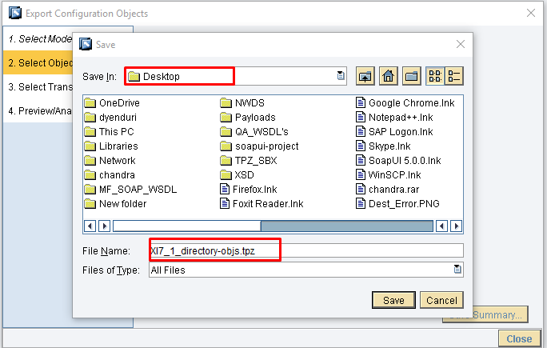

Finally you will find the below successful message.

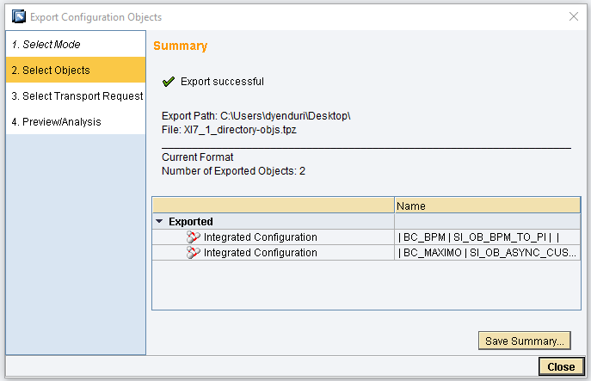

For importing objects in Integration Directory (ID) same as ESR.